**Experiment Number - 7**

**Student Name:** ANIKET KUMAR **UID:** 20BCS5306

**Branch:** CSE **Section/Group:** 20BCS_WM-703 / B

**Semester:** 5th **Date of Performance:** 13th Oct, 2022

**Subject Name:** PBLJ LAB **Subject Code:** 20CSP-321

1. **Aim/Overview of the practical:** Write a Program to perform the basic operations like insert, delete, display and search in list. List contains String object items where these operations are to be performed.

**2. Hardware and Software Requirements :**

PC with windows installed,IntelliJ IDEA (IDE).

**3. Program Code:**

import java.util.ArrayList;

import java.util.Scanner;

class MyList{

Scanner sc = new Scanner(System.in);

ArrayList arrLi = new ArrayList<String>();

public void insertItem(){

System.out.print("Enter an element in list :");

String element = sc.next();

arrLi.add(element);

}

public void displayElement(){

System.out.print("List elements are - ");

for(int i=0; i<arrLi.size(); i++){

System.out.print(arrLi.get(i) +" ");

}

}

public void deleteElement(){

System.out.print(" Enter index of list you want to remove :");

int i = sc.nextInt();

arrLi.remove(i);

}

public void searchElement(){

System.out.print("Enter key value you want to search in the given list :");

String key = sc.next();

int found = 0;

for(int i=0; i<arrLi.size(); i++){

if(key.equals(arrLi.get(i))){

found = 1;

System.out.println(key+" is found at index "+i);

break;

}

}

if(found != 1) {

System.out.println(key + " is not found in the given list");

}

}

}

public class Main{

public static void main(String[] args) {

MyList li = new MyList();

Scanner sc = new Scanner(System.in);

int temp = 1;

while(temp != 0) {

System.out.println("1.Insert");

System.out.println("2.Delete");

System.out.println("3.Search");

System.out.println("4.Display");

System.out.println("5.Exit");

System.out.println("Enter a choice(1-5):-");

int choice = sc.nextInt();

switch (choice){

case 1:

li.insertItem();

break;

case 2:

li.deleteElement();

break;

case 3:

li.searchElement();

break;

case 4:

li.displayElement();

break;

case 5:

temp = 0;

break;

default:

System.out.println("Incorrect choice! Please enter a correct choice.");

}

}

}

}

**4. Output :**

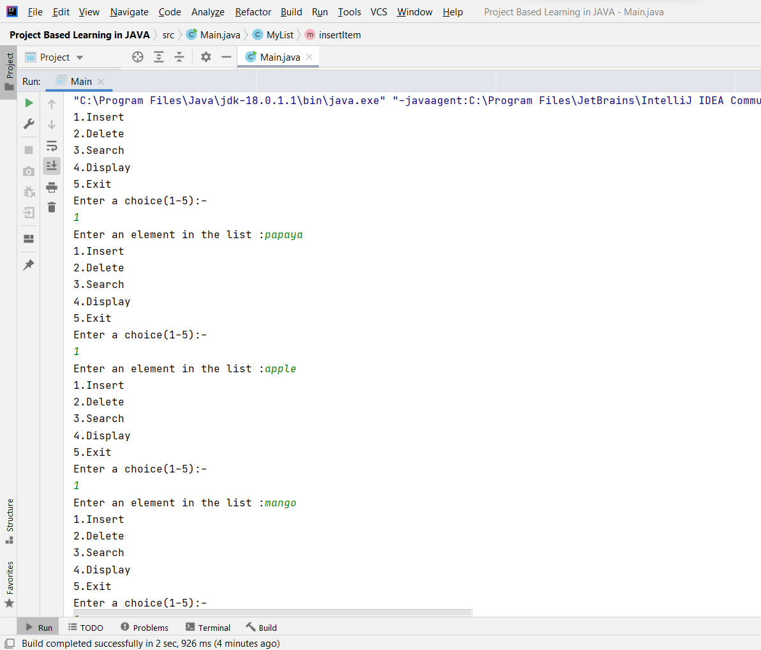

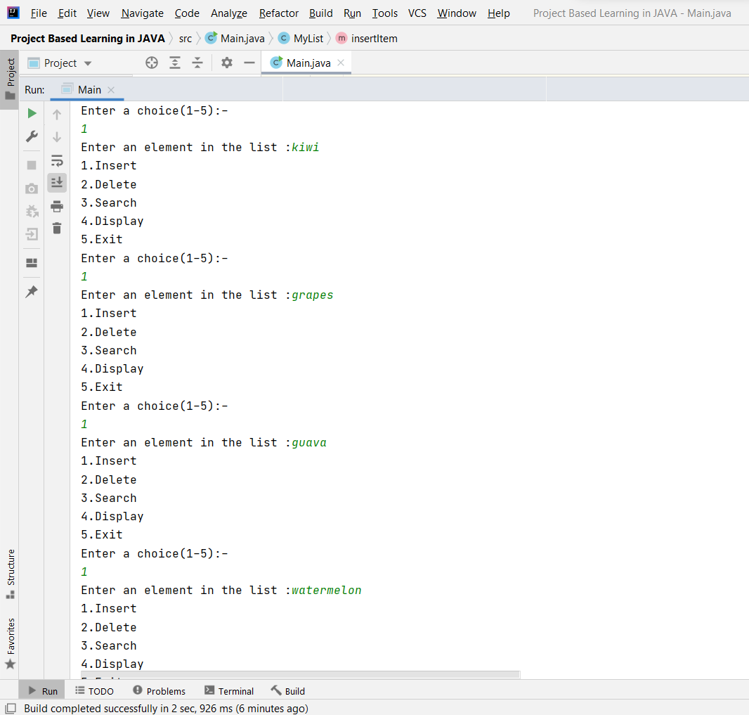

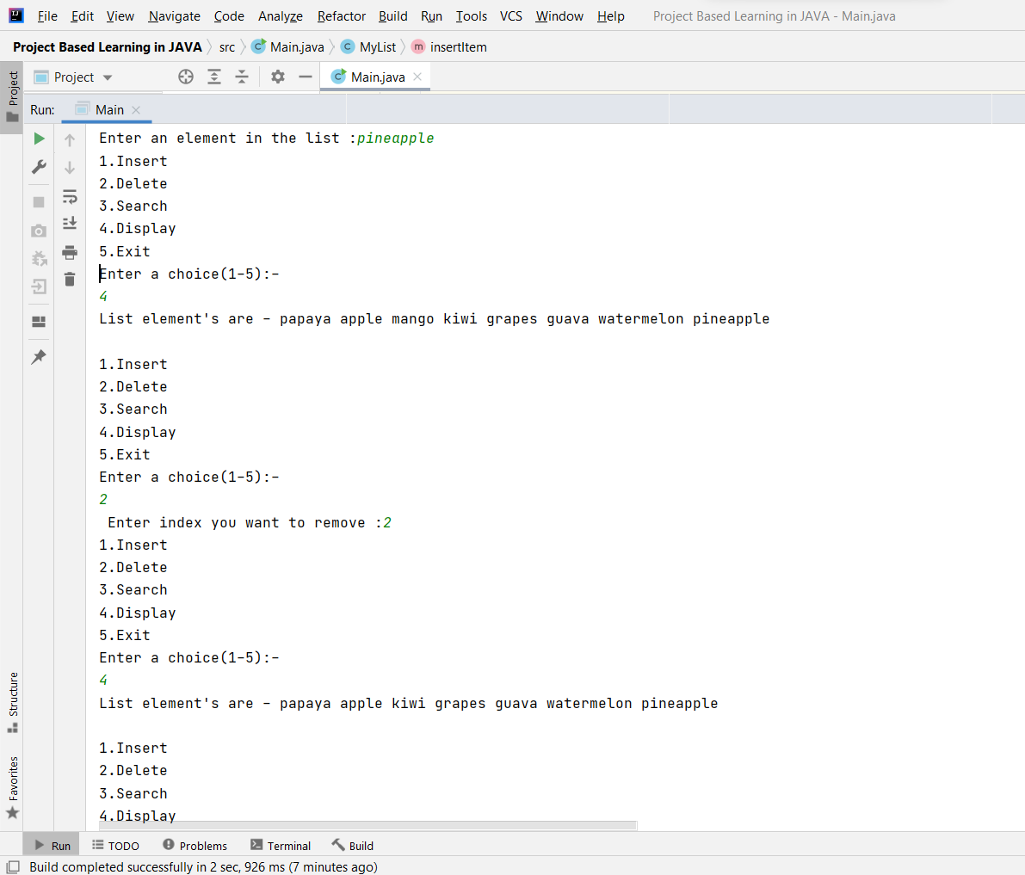

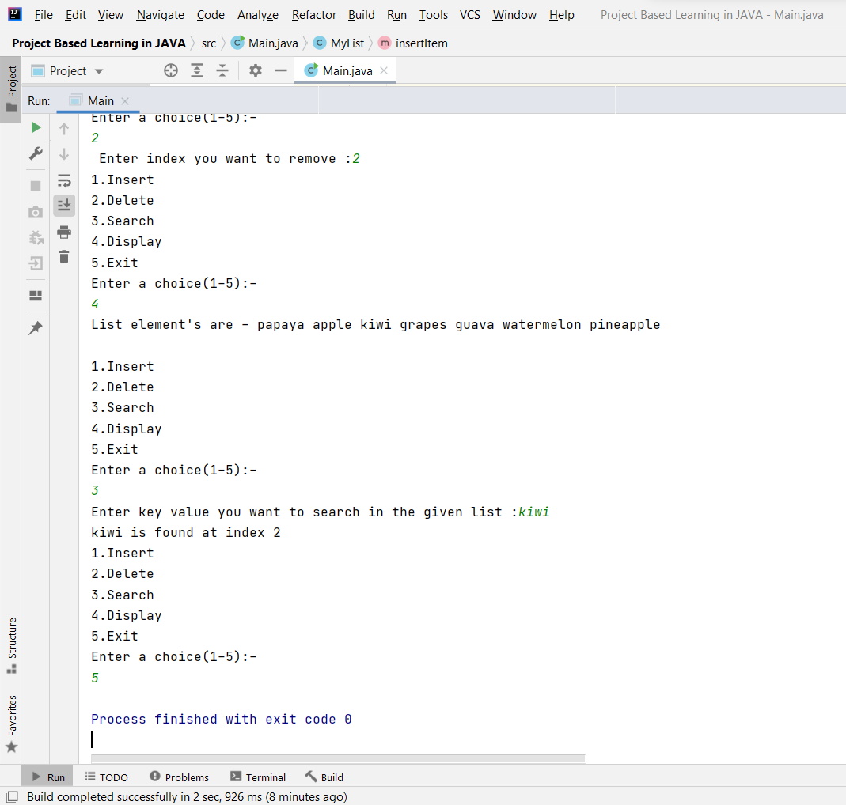

**Learning outcomes (What I have learnt):**

1. I have learnt how to write program in JAVA.
2. I have learnt how to create classes and its objects in JAVA.
3. I have learnt how to take input from user using Scanner class.
4. I have learnt how to create Array in JAVA and traverse each elements using loop.
5. I have learnt how to create an application to perform the basic operations like insert, delete, display and search in list.

**Evaluation Grid (To be created as per the SOP and Assessment guidelines by the faculty):**

|  |  |  |  |
| --- | --- | --- | --- |
| Sr. No. | Parameters | Marks Obtained | Maximum Marks |
| 1. |  |  |  |
| 2. |  |  |  |
| 3. |  |  |  |
|  |  |  |  |